Date

Company
Address

Attention: Name

RE: GCA 6839: 2022 Water Resistant Membrane for Waterproofing Concrete
And Insulated Concrete Form (ICF) Foundation Walls

Dear ___________________,

Global Coatings Advisors is pleased to inform you that Hulk WP waterproofing membrane for concrete and insulated concrete form (ICF) foundation walls is recommended. Hulk WP conforms to the GCA 6839: 2022 specification.

The GCA 6830:2022 specification is to establish the minimum level of requirements for
recognition of both sheet and liquid water-resistant membranes in Global Coatings Advisors and evaluation reports under:

- Division B of the National Building Code of Canada 2015 (NBC 2015)
- The 2003 International Building Code (IBC)
- The 2003 International Residential Code (IRC)
- The BOCA National Building Code (IBC)/1999 (BNBC)
- 2015 (NBC 2015), the 2003 International Building Code (IBC), the 2003 International Residential Code (IRC), the BOCA National Building Code /1999 (BNBC),
- The 1999 Standard Building Code (SBC) and the 1997 Uniform Building Code (UBC) in the areas defined by the objectives, a foundation wall waterproofing.
- The product is intended to be installed on cast-in-place concrete, concrete block, unit masonry, sheathing, or insulated concrete form (ICF) substrates.

To maintain the confidentiality of the GCA specifications, I wish to emphasize that their distribution should be strictly controlled and limited to authorized parties. Any dissemination of the documents must be approved exclusively by me, as per the requirements for confidentiality and protection of proprietary information.

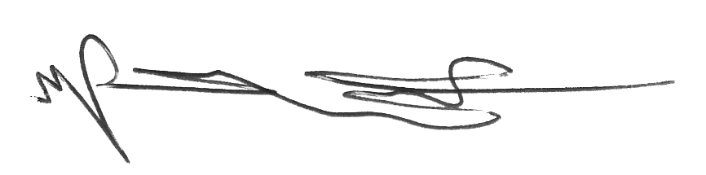

Shiwei William Guan, Ph.D.
Vice President of Technology & Principal Advisor - Global Coatings Advisors
AMPP CIP & PCS Instructor | Senior Certified Coating Inspector (#N-9484) – AMPP (NACE/SSPC)
Technical Specialist (Stamp# CA-0104) - Intertek Inspection Services Ltd.

